The Myer Department Store Strategy
Background
The first Myer was opened on 1900 in Bendigo Victoria by the two Myer brothers, Sydney Myer and Elcon Myer. They further opened the second store in 1908. They began to purchase other businesses and companies in 1911 by Bourke Street’s Drapers and later buildings around Australia. It was listed in The Australian stock exchange in 1925and grew over time to become one of Australia’s most adored and spread out stores having purchased and absorbed numerous companies and businesses (Vernon, 2010). By 1935, the company had a capital base of over £2,500,000 and employed over 5300 people.
The company was originally owned by the Myer brothers under the leadership of Sydney Myer, Then Elcon Myer and then Norman Myer. It opened up its shares as a publicly trading company in 1935 after being listed on the Australian Stocks exchange. That was done under Myer Emporium. In 1985, the company merged with GJ Coles and Coy to form Coles Myer. In 2006, the Coles Myer divested in Myer to remain with Myer and the Coles Group separately. They were bought by a US-based consortium to later e owned by Newbridge Capital and the Myer family. Till to date, they still have kept making purchases and mergers with companies and investors such as David Jones Limited (Vernon, 2012).
Myer Company is one of the largest departmental stores in Australia and outside its states. It is the only chain that has a store in every one of Australia’s state and two independent states outside the Australian protectorate. Its store locations are a mixture of main city center stores, suburban shopping centers, and high street and shopping centers in regional Victoria, New South Wales, Queensland, and Tasmania. With a target of over 80 stores by 2014, Myer runs its stores in four clusters which determine the size, services offered, capital expenditure, product assortment, and merchandise mix (Ilicic & Webster, 2011). The cluster numbers include Flagship (7), Premium (16), Mainstream (27), and Community (17). Each cluster number is vulnerable to appraisal or downshifting in the case of market changes.
Products and services
Myer deals in various classes of products from men’s clothing, footwear, women clothing, fragrance, children's clothing, cosmetics, home wares, electrics, furniture, bedding, toys, books and stationery, food, confectionery and travel accessories. Their services range from online shopping to deliveries, fashion events, and shows, among others. They offer a wide range of consultation and fashion mentoring. Their main target includes the individuals in all their departments such as children, men, women, fusionists, sports people, among other, they not necessarily base their market only in Australia but also in Sidney, the US and many countries all over the world. Their specific target market is also determined by the cluster numbering of the stores as per their location and operation (Bailey, 2016).
External economic environment risks
There are some macro factors which have affected the Myer in the daily business operation. The company has been forced on a regular basis to evaluate and develop economic data to avert the situation (CHEN et al 2014). Some of the elements which are affecting the company include the fluctuation of the Australian dollar which is reducing the company ability to purchase. For example the company stock hit the significant low in 2010 2012 and 2014 respectively getting as low as $0.9 per share due to the fluctuations of the dollar.
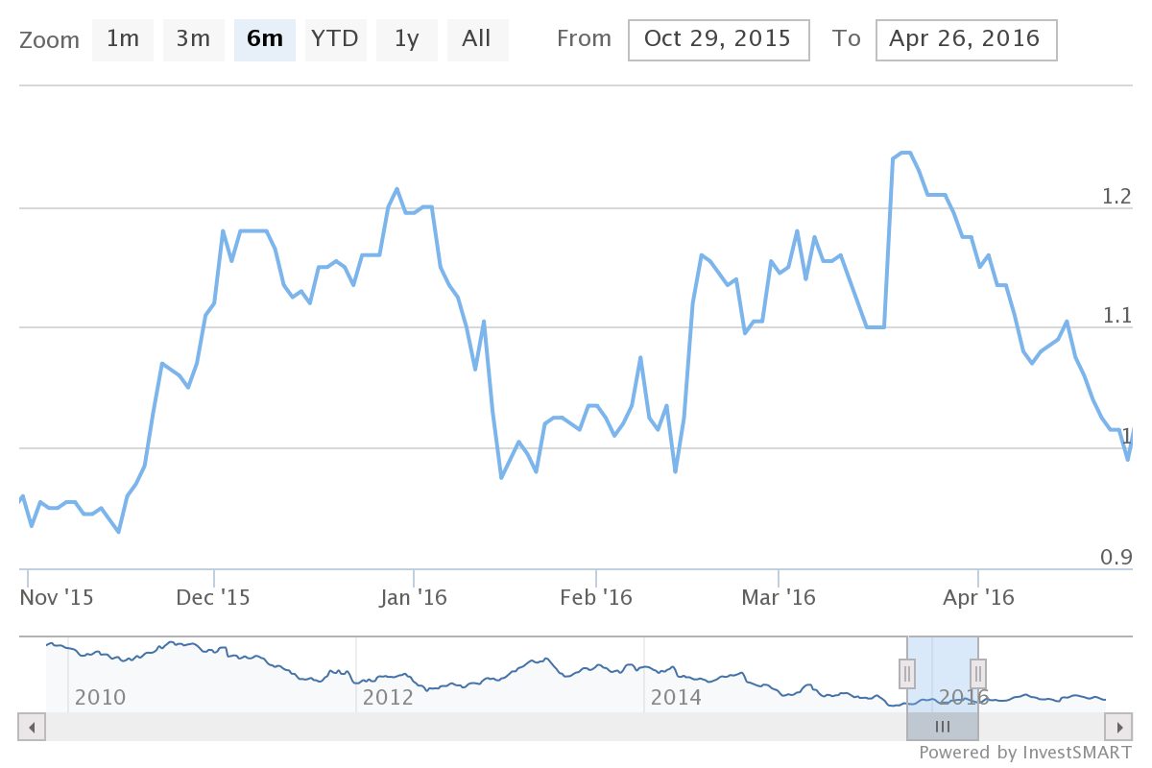
Second, is weak consumer confidence that is reducing the number of customers who are visiting the store? The third element is the changes to government regulations and weakness in the overall global economy. The company has been forced to implement conservative hedging as it tries to solve the external market forces which are likely to disrupt its operations (Snieška, 2015). Other initiatives such as marketing and merchandise initiatives been developed to combat the global economic crisis which is affecting the company.
Myer operates in the Australian retail industry which is very competitive. Development of online stores is offering a critical challenge to the company (Snieška, 2015). Other elements which are posing great challenge includes new international and domestic company which are entering the market and also the existing competitors such as Wesfarmers Limited and David Jones Pty Limited. The combination of these is offering high competition level which needs to be reduced for the company to be safe in the market. As the way forward Myer has a diverse new mechanism that can be used in the process of solving the problem. These mitigation elements include investing on specific customer areas. Second is store networking and Omni-channel market alignment which is offering something tangible into the market (Durán et al 2016). The last mechanism that the company has used is merchandise marketing option which is developed with the sole aim of trying to provide compelling offers to the customers which are based on the need of the external. It has enabled the company to align with the external market demand.
Myer stores however enjoy a great stand out for their community relations and community based charity and philanthropic activities which include their Myer community investment, Myer community partnerships and Myer Stores Community Fund. They input their assets in supporting organizations that support the communities in which they operate directly, promote business partnerships with their local communities in areas related to their operations and conduct fund raisers that promote women empowerment and other charity operations within the communities.
Porter’s 5-forces model
Supplier power: Myer has around 1200 suppliers globally among whom there are many community based partnerships. Over the time the market is no longer dictated by the suppliers but those companies that have enough power at their disposal to change the supplier value. In fact, the company with D Jones had been able to control the supplier’s value by trying to dictate the overall pricing which the suppliers have been using (Anton, 2015). Myer can be able to argue with the suppliers to reduce the overall prices of the products. At the long run, the economic scale which is gathered will be reflected as the retailers business. With this, it seems that the power that the suppliers had
Industry competition: D Jones have been offering increasing competition level in the market to Myer with this respect the company has been to the put to try and develop new strategies which can be used in the market to make sure that it aligns with the current needs. To revitalize the company it has resolved to improve the Omni-channel capabilities which give it better market position. Second is reallocating space to the popular brands which will make the customer affiliated to these brands have their value maintained (Ceptureanu et al 2016). Other initiatives include more flexible in store labor strategies. The company has also started store refurbishment to make it look better than the competitors and also opening new stores and developing additional capital investments. The company is working to make sure that it reduces the inventory costs. And reduce the capital shrinkage.
New entrants one of the biggest challenges that are facing Myer is the entry of new companies into the business. The result has been shrink in the market size of the company which is resulting in more problems in the market (Suwardy, et al 2016). Online stores are also offering considerable pressure to the company, and this is creating more problems to the company. The fact that the company is operating in the regulated environment means that it must respect and work with the required process. Some laws such as mandatory compliance standards privacy act must be considered in the business. The best mitigation measure that the company has used is brand recreation.
Substitutes; Myer understands that most companies are developing new products concerning the market changes and customers wants. With this, the company has tried to incorporate products which can be affiliated with any group (Ruizalba, & Soares, 2016). With this, the idea has been the use of lower prices and getting quality products by the end and thus giving every customer something of his or her choice. Production of diversified services has also been in line.
Bargaining power of buyers; buyers have little do with when it comes to the bargain in Myer. Most of the products have their specified prices. The fact is that even though it is a retail shop, it must maintain its value of the purchase by the end with this pricing is concerning the supplier's cost element. The only thing theta the buyers have is just fair pricing (Tejeiro Koller, & Tejeiro Koller, 2016). In the long run, Myer cannot reduce the prices while the product are not cheap or the quality does not dictate it to be done.
Resources and competitive advantage
Over time, despite fluctuations, Myers has had a major success in its businesses especially concerning their role in the Australian market. Now, Myers is one of the largest and most successful department store chains in Australia and beyond. Their product has gained popularity both online and physically while opening more and more stores in many other locations around. They attribute their success to the following resources and competencies:
Online resources – Myers is an online master with its online marketing processes. They have one of the most elaborate online marketing hubs. Their website is easy to use and easily accessible while allowing trolley system where shoppers can add items to their virtual trolleys and purchase when ready from any of the store locations. It is also open to membership registration and logins so that members can log in and access shops though they can access without registering on limited service access. Customers can access a greater deal of all the products available in the shops while conducting extensive promotions and advertisements on the website. It is open to response and blog activity as well (Miller et al., 2016). For example, their website is shopping enabled in that customers accessing can place orders through placing the products they are interested in on their online trolleys awaiting purchase. They also have a Facebook shopping site where customers can access their products and place orders online. The orders can then be delivered in policy.
Product quality – The products and services offered by the Myers are highly diverse while covering more than five product categories. The convenience of the stores does not only lie in their availability and diversity but also their quality. The one thing that united the many different products of Myers is their outstanding quality. Quality also leads to customer trust for Myers.
Pricing strategies – Myers uses cut-the-throat pricing strategy. The strategy enables then to keep track of their diverse product and client base while also making sure of catering for the market differentiation, especially for the numerous target market categories (Stein & Ramaseshan, 2016). Myers targets all customer class including lower classes, middle classes, and high social classes. It is in that differentiation that they differentiate their store with cluster numbers indicating the surrounding and target market for each store.
Brands - One of the most advantageous things for Myer against their competitors is the wide coverage of brands. Myers invests in their brand names. The investment has over time been characterized by mergers and purchases of big brand names in the recent past. They have the highest variety of brands from clothing, furniture, food, cosmetics, and mechanicals among many others. They diversity also makes them stand out as well as the strict maintenance of high quality. Their branding strategy all together sells Myers as a sleek, classic product affordable for as many.
Geographical coverage – Myers has its stores and building distributed all over Australian states and even beyond. It is the only chain that owns a store in every one of Australia’s states. They also have a target of increasing their stores further. That makes them stand out from their competitors over their geographical accessibility.
Conclusion
Myers Stores have gained a big share of market success in their lifetime. It is based on their strategy and their market characteristics that they have had such a success. Myers caters for the bigger picture of the market by devising strategies that help the company enter and maintain their markets while maintaining their ability to penetrate the market further. They also development strategies of improving their competencies and maintaining their attractive traits while disregarding their unattractive traits for success. Expansion and controlling a bigger character of their market base while effectively segmenting their market are also some of the strategies.

References
Anton, R. (2015). An Integrated Strategy Framework (ISF) for Combining Porter's 5-Forces, Diamond, PESTEL, and SWOT Analysis.
Bailey, M. (2016). Absorptive Capacity, International Business Knowledge Transfer, and Local Adaptation: Establishing Discount Department Stores in Australia. Australian Economic History Review.
Bailey, M., & Bailey, M. (2016). Marketing to the Big Middle: establishing Australian discount department stores. Journal of Historical Research in Marketing, 8(3), 416-433.
Ceptureanu, S. I., Ceptureanu, E. G., & Luchian, C. E. (2016). COMPETITIVENESS ASESSMENT: AN OVERVIEW. Annals of the University of Oradea, Economic Science Series, 25(2).
CHEN, Q., XIAO, J. H., & LIU, R. M. (2014). Macro-environment Analysis of General Practitioners on Standardized Training Based on PEST Model. Chinese General Practice, 34, 024.
Durán, C., Córdova, F., & Palominos, F. (2016, October). Multi-criteria analysis of strategic synergy relationships between a medium-sized port and its macro-environment. In Automatica (ICA-ACCA), IEEE International Conference on (pp. 1-6). IEEE.
Ilicic, J., & Webster, C. M. (2011). Effects of multiple endorsements and consumer–celebrity attachment on attitude and purchase intention. Australasian Marketing Journal (AMJ), 19(4), 230-237.
Lee, Y., & McCracken, M. (2012). Centripetal and centrifugal movement: Shopping centres in Denver, USA, and Brisbane, Australia. Urban Studies, 49(7), 1489-1506.
Miller, D., Miller, D., Merrilees, B., & Merrilees, B. (2016). Department store innovation: David Jones Ltd., Australia, 1876-1915. Journal of Historical Research in Marketing, 8(3), 396-415.
Ruizalba, J., & Soares, A. (2016). Internal Market Orientation and Strategy Implementation. In Strategic Labor Relations Management in Modern Organizations (pp. 183-194). IGI Global.
Snieška, V. (2015). Research into international competitiveness in 2000–2008. Engineering Economics, 59(4).
Stein, A., & Ramaseshan, B. (2016). Towards the identification of customer experience touch point elements. Journal of Retailing and Consumer Services, 30, 8-19.
Suwardy, T., & Ratnatunga, J. (2014). Business landscaping for strategic advantage: Evidence from a multi-sector study. Journal of Applied Management Accounting Research, 12(2), 1-15.
Tejeiro Koller, M. R., & Tejeiro Koller, M. R. (2016). Exploring adaptability in organizations: Where adaptive advantage comes from and what it is based upon. Journal of Organizational Change Management, 29(6), 837-854.
Vernon, P. (2010). American know-how & the Myer Emporium.
Vernon, P. (2012). Shopping Towns Australia. Fabrications, 22(1), 102-121.

